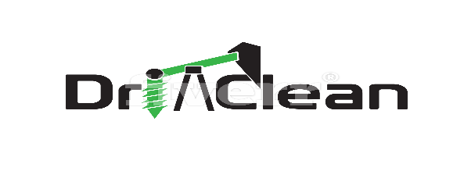
Distributed by Geo-Explore Store (Pty) LTD

Providing acceptable environment solutions to Hydrocarbon waste in the Exploration Drilling Industry

Introduction

The Exploration industry is located in remote areas were waste and hazardous disposal facilities are non-existed.
Drillclean provides a complete range of environmentally products that protects the environment from contamination, remediates contaminated soil and elevates waste disposal.
The innovative Soil Clean Soil Remediation Technology has evolved over a period of 15 years through collaboration amongst a team of chemical specialists, ecologist and Environmentalists. This unique technology has been extensively researched in laboratory and fields trials.
SoilClean Soil Remediation.
SoilClean has successfully treated sites contaminated with the following hazardous substances
Crude Oil, Diesel, Petrol, Jet Fuel, Motor oil, Grease, Hydraulic fluids, drilling Polymers
PCB,s Alcohols, Chlorinated Solvents, Dichloromethane, Carbon, Terachloroethylene,
Terachloride,1,1 Dichloroethene, Toxiphenes, Pentachlorphenol, Perchlorate, Explosive wastes [nitrate compounds] Sulphuric contaminated soil.
SoilClean is easy and safe to use in any soil remediation situation. The microbes present aggressively seek out their food source [hydrocarbon]converting it to carbon dioxide, water and a biomass in a short time frame bring the contaminated soil back to its pre contaminated state.
The species of selected microbes and Enzymes in Soil Clean degrade hydrocarbon chains ranging from C1 –C100
SoilClean is non-hazardous, non-toxic, non-pathogenic, and safe to nature thus no special handling required.

Typical Applications

Oil Spills. Wash bay and Oil & Grease trap sludge.
Protector mats and Protector Booms.
The all natural fiber Protector Mats and Booms are position in strategic positions to absorb oil and polymers in the drilling sump and under the mechanical machinery to absorb leaks and spillage of hydrocarbons.
Once saturated the Protector Mats and Booms are removed and buried with the Soil Clean remediation technology which converts the encapsulated hydrocarbon into carbon dioxide, water and a Biomass in a short time frame.
Sump Clear
Once the drilling operation has ceased and the rig removed. Sump Clear is added to the sump to break the molecular structure of the hydrocarbons and polymers present, once its action is completed the sump is skimmed with the use of H2º Oil Absorbent to absorb the hydrocarbon and polymer residue. The waste water is pumped through the Protector Booms directly into the environment providing a clean COD enriched (Chemical Oxygen Demand) waste water.
The spent H2º Oil absorbent is then transferred and included in the Soil Clean remediation location
HC Hydro Carbon Absorbent
Is a natural readily biodegradable oil absorbent that quickly absorbs oil and is transferred to the Soil Clean remediation location for rehabilitation once spent.
Bio Wash
A user friendly solvent less water based degreaser that quickly cleans and degreases equipment and hard surfaces.
Rig Oil Spill Kit
The kit is housed in a Red wheelie bin which includes a Spade, Fork & Rake, 10kg H2º Oil Absorbent and Soil Clean Soil Remediation Kit. Refill kits are readily available.

